BOOTSTRAP ASSIGNMENT

1. What are the advantages of Bootstrap?

Ans. Access to Support, Fast Development, Responsive Business Actions with a Grid System, Customizable Expansion, Loaded JavaScript Components, Easy to Integrate.

Example:

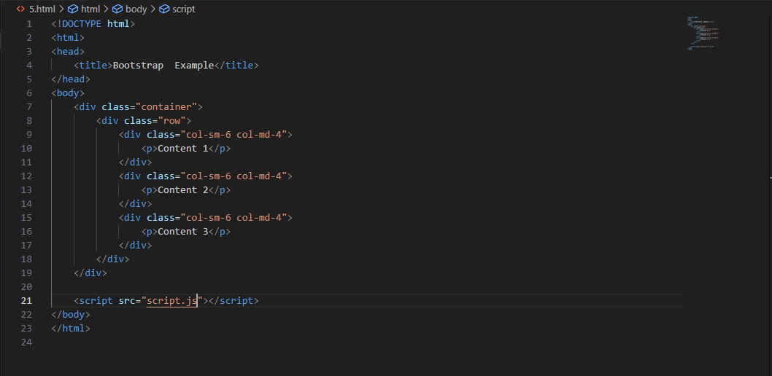

Output:

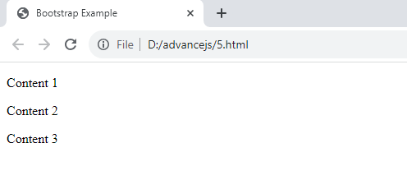

2. What is a Bootstrap Container, and how does it work?

Ans In Bootstrap, container is used to set the content's margins dealing with the responsive behaviors of your layout. It contains the row elements and the row elements are the container of columns (known as grid system).

Example:

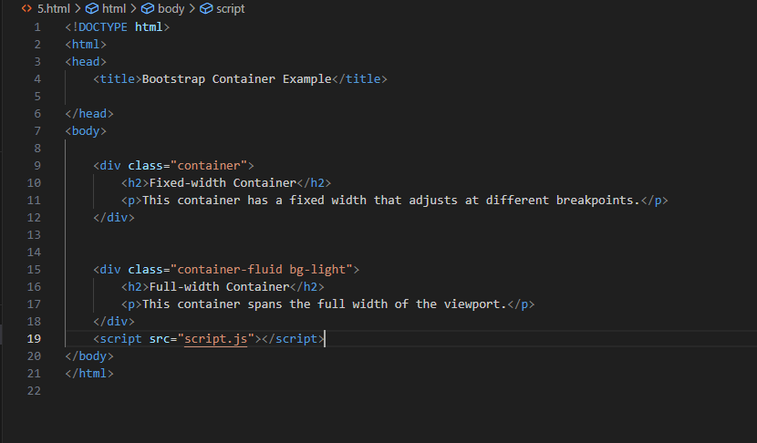

Output:

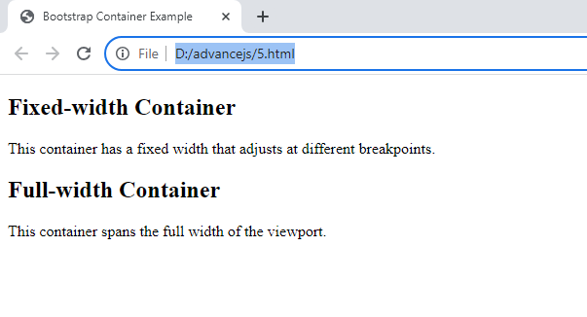

3. What are the default Bootstrap text settings?

Ans. Default font-size is 16px, and its line heights is 1.5 the default font-family is Helvetica, sans-serif, arial.

4. What do you know about the Bootstrap Grid System?

Ans. bootstrap grid system uses a series of containers, rows, and columns to layout and align content. It’s build with flex box and is fully responsive.

Example:

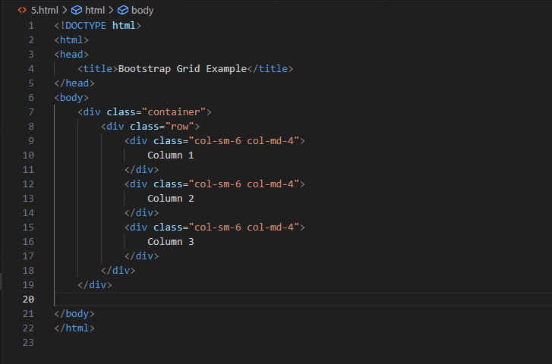

Output:

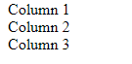

5. What is the difference between Bootstrap 4 and Bootstrap 5

Ans. bootstrap 5 has six level xs, sm, md, lg,xl,and xxl. Bootstrap 4 includes jquery and all associated plug-ins.

6. What is a Button Group, and what is the class for a basic Button Group?

Ans. button group is used to create a series of button in groups vertically or horizontally. Class for the button group is btn-group.

Example:

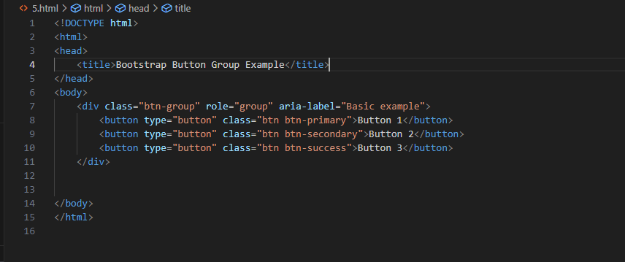

Output:

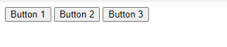

7. How can you use Bootstrap to make thumbnails?

Ans. To create thumbnail using bootstrap, you can use the ‘.img-thumbnail’ class on an <img> element to automatically style and size the image as a thumbnail.

Example:

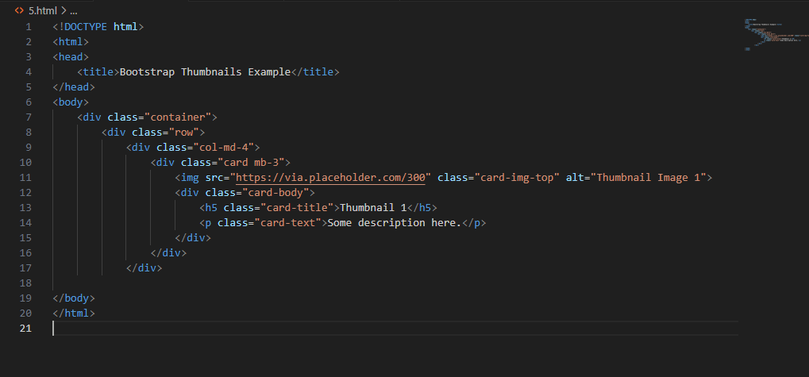

8. In Bootstrap 4, what is flexbox?

Ans. in bootstrap 4 , flexbox is a layout system that provides an efficient way to arrange and align elements within a container, enabling responsive and dynamic design.

Example:

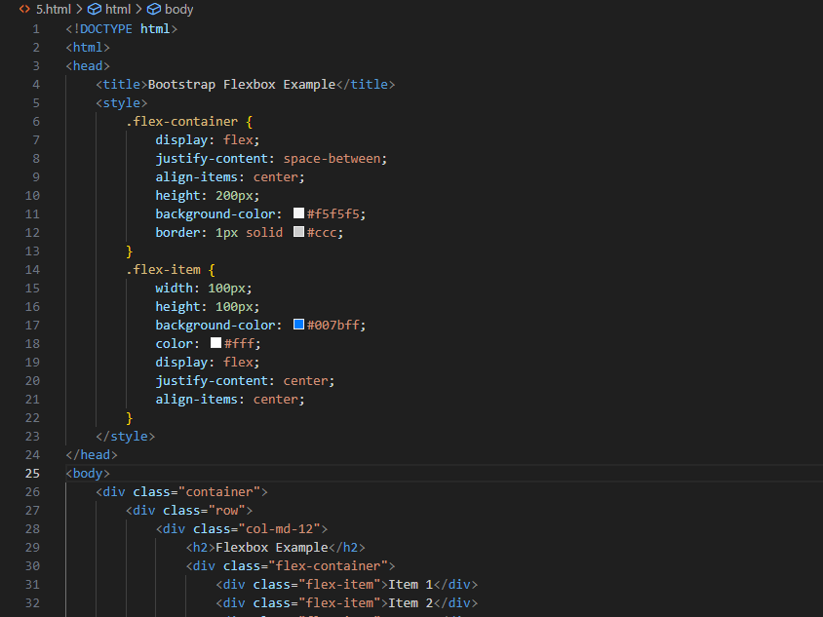

Output:

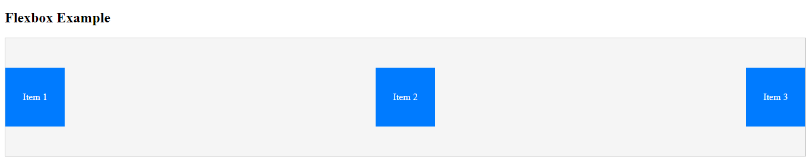

9. How can one create an alert in Bootstrap?

Ans. Bootstrap provide an easy way to create an alert message in bootstrap.

Example:

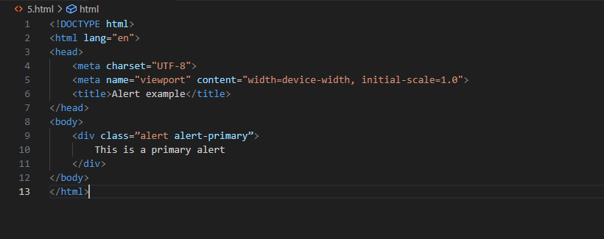

OUTPUT:



10. What is a bootstrap card and how would you create one?

Ans.

EXAMPLE:

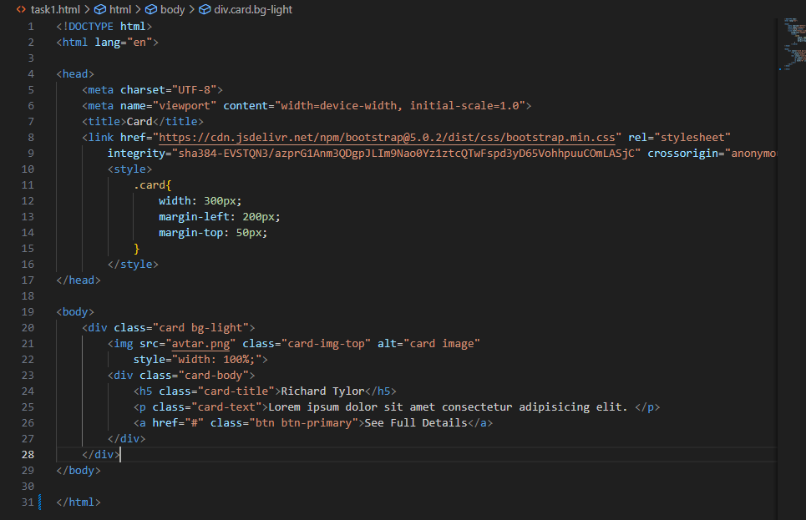

OUTPUT:

